2016 screenshot of working code

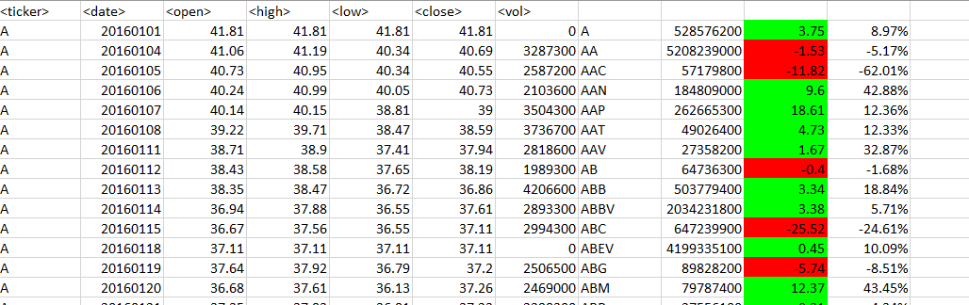

2015 screenshot of working code

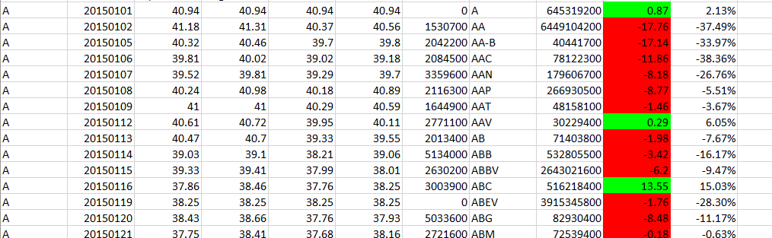

2014 screenshot of working code

